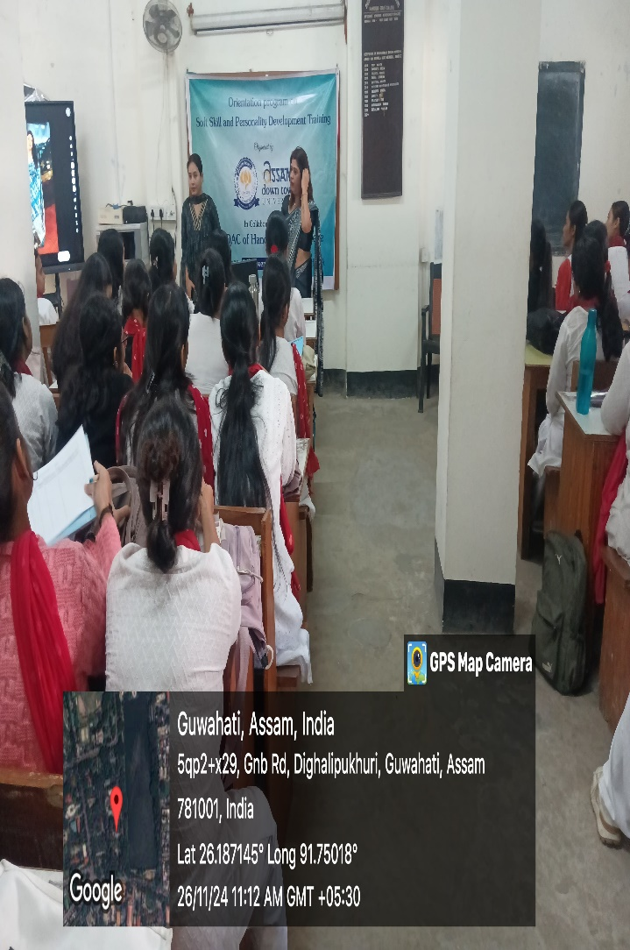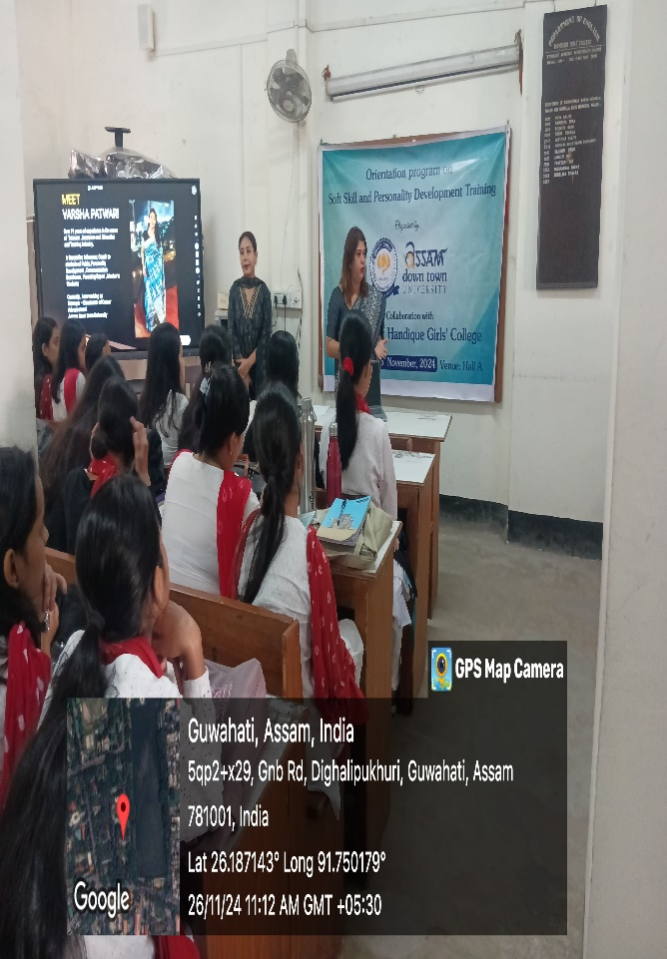
Orientation program on Soft Skill and Personality Development Training organised by Assam Down Town University in collaboration with IQAC, HGC on 26th November 2024.

